

 **FEASOMED**

**PROJECT REPORT**

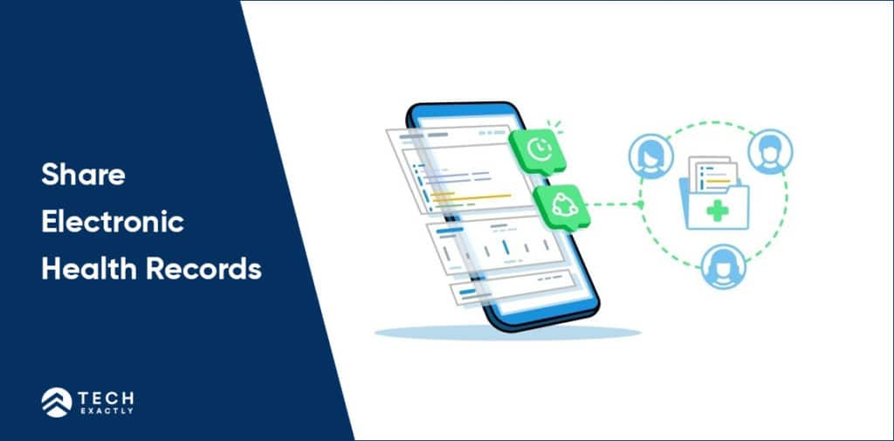****



**Programmed and Presented by:**

GOPAL MENGI (CO20320)

UDAY MADAN(CO20365)

DEEPAK MAHTO(CO20318)

**ACKNOWLEDGEMENT**

The credit for the successful completion of this project work goes beyond our own work, to those people who have always been with us throughout. And we take this opportunity to express our heartfelt gratitude to each one of them.

We express our sincere thanks to our Mentor **Dr. Sarabjeet Singh** of for his valuable suggestions and providing guidance throughout the project, that enabled us to complete this project successfully.

**Abstract**

The main aim of our project is to provide a feasible method to all the rural hospitals to order the required products for the smooth functioning of the hospitals.

This project is intended to generate a supply chain which is easy to manage for everybody associated with it.

**Table of Contents**

1. INTRODUCTION................................................................................................

2. SYSTEM ANALYSIS.........................................................................................

2.1 EXISTING SYSTEM.....................................................................

2.2 PROPOSED SYSTEM .................................................................

2.2.1 SCOPE OF THE PROJECT ........................................

3. AIM OF THE PROJECT....................................................................................

4. PROJECT MODULES ......................................................................................

5. COMPILER SPECIFICATIONS .......................................................................

6. SYSTEM DESIGN............................................................................................

6.1 FLOW CHARTS ........................................................................

7. SYSTEM IMPLEMENTATION ........................................................................

7.1 MODULAR DESCRIPTION........................................................

8. RESULT..........................................................................................................

9. CONCLUSION ................................................................................................

10. REFERENCES...............................................................................................

**1.INTRODUCTION**

The “FEASOMED” is our substitute to the present supply chain system which is very cumbersome. The targeted audience are the hospitals in the rural areas. It is hard in the present system to get the necessary equipment and the medicines needed for the hospitals i.e, they have to go through a very long procedure in order to get them which is not good for the healthy working of the hospital.

In our system, we have designed a portal for everybody at every level to order and procure the goods. We have divided the chain in 4 stages and at every stage one can order the goods, check their status and receive the products.

**2. SYSTEM ANALYSIS**

**2.1 EXISTING SYSTEM**

Currently there is no such system available for this. The hospital itself has to call the CMO office and they then call the health ministry to give the necessary products.

**2.2 PROPOSED SYSTEM**

**2.2.1 SCOPE OF THE PROJECT**

THE MAIN AIM OF THE PRODUCT IS: -

* To make the ordering process easier for the hospitals and any user for that matter.
* To make the medicines and equipment easily available to the hospitals.
* This is a generic supply chain portal which can be used for any product and any user.
* This software has a very broad scope in the field of supply chain programs/systems.

**3. AIM OF THE PROJECT**

This project is aimed to provide a tool for easy procurement of the goods and so that the supply chain is not disturbed.

The main aim of the project in hand is to provide an improved, faster and instant approach to order the equipment and medicines so that a lot of lives could be saved even in the remote areas.

**4. PROJECT MODULES**

The project has been slashed into many small modules to run effectively, easy to understand and debug. Some of the modules are the main/central storage unit, state storage unit, regional storage unit, hospital’s storage and to manage them all we have the admin.

**5. COMPILER SPECIFICATION**

To design this program, we have used mingw as the compiler. Visual Studio Code as the code editor. Some standard header files are used for building of the program.

The visual presentation is managed in simpler way, so that it is accessible to all people. This program uses features like file handling in C++. Also, we have used concepts of Object-Oriented Programming so that inly the required functions are visible to the user and not the backend features.

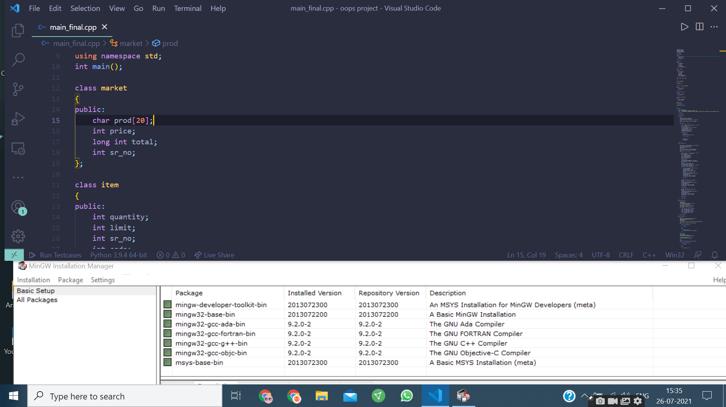

**6. SYSTEM DESIGN**

**6.1 FLOW CHARTS**

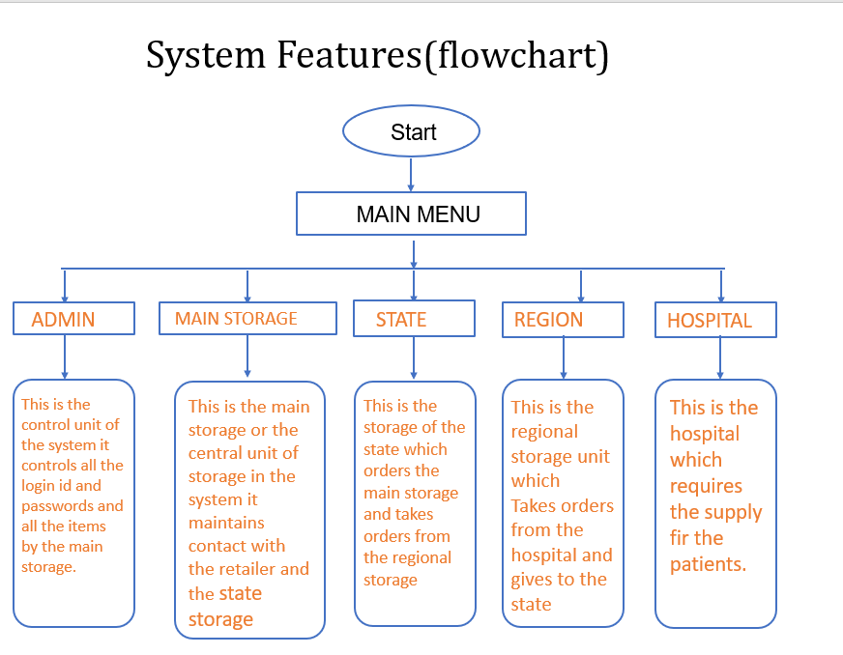

**7. SYSTEM IMPLEMENTATION**

The program has been designed by making use of different modules and these modules help each other in the effective working of the program to give a specified result.

**7.1 MODULAR DESCRIPTION**

**The project has been slashed into many small modules to run effectively, easy to understand and debug. Some important modules used in the project are:**

* **ADMIN (CONTROL UNIT)**
* **HOME MODULE (MAIN MENU)**
* **MAIN STORAGE**
* **STATE STORAGE**
* **REGIONAL STORAGE**
* **HOSPITAL STORAGE (GENERIC ==> RETAIL STORAGE)**

**Home Module: This module gives the information about the different tabs that are being used In the program.**

• **The user can make use of this home module to know about the tabs which he or she has to make use.**

• **In the program we have made use of tabs like the status of the user whether it is main storage , state , hospital or region.**

• **This module gives a overview of all other tabs.**

**MAIN STORAGE ,STATE STORAGE REGION ,HOSPITAL :-**

**They have different options related to their usage which makes the handing easy.**

**8. RESULTS**

1)MAIN MENU

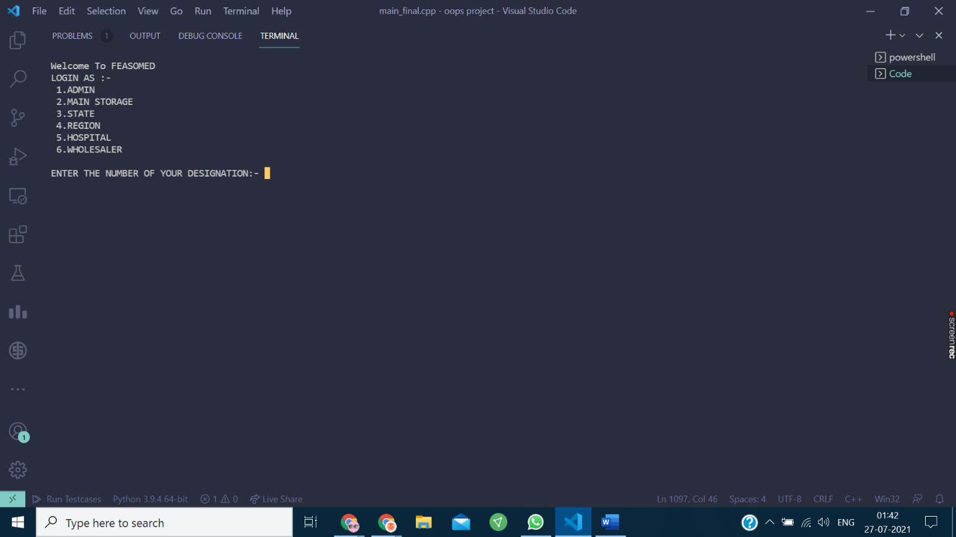

2)ADMIN INTERFACE

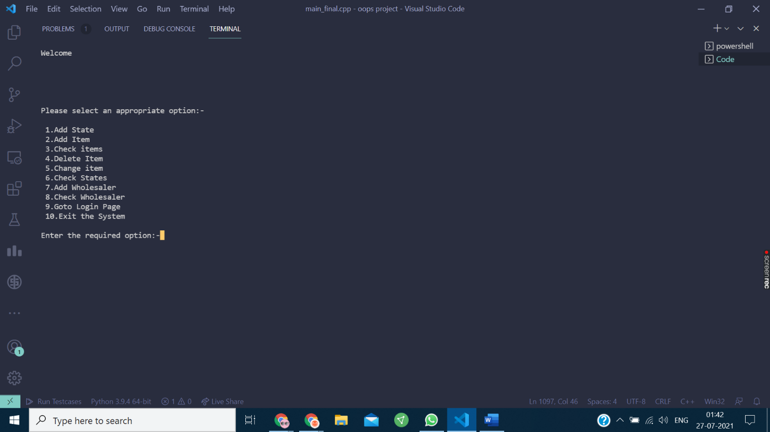

3)MAIN STORAGE INTERFACE

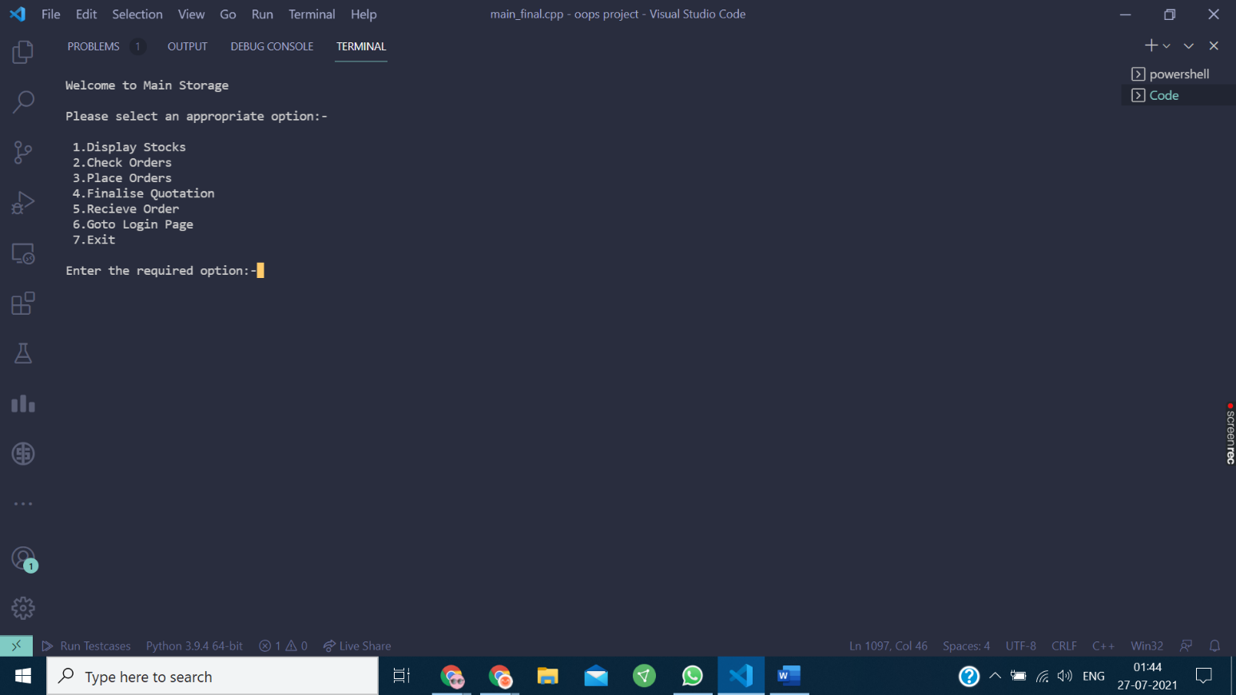

4)STATE INTERFACE

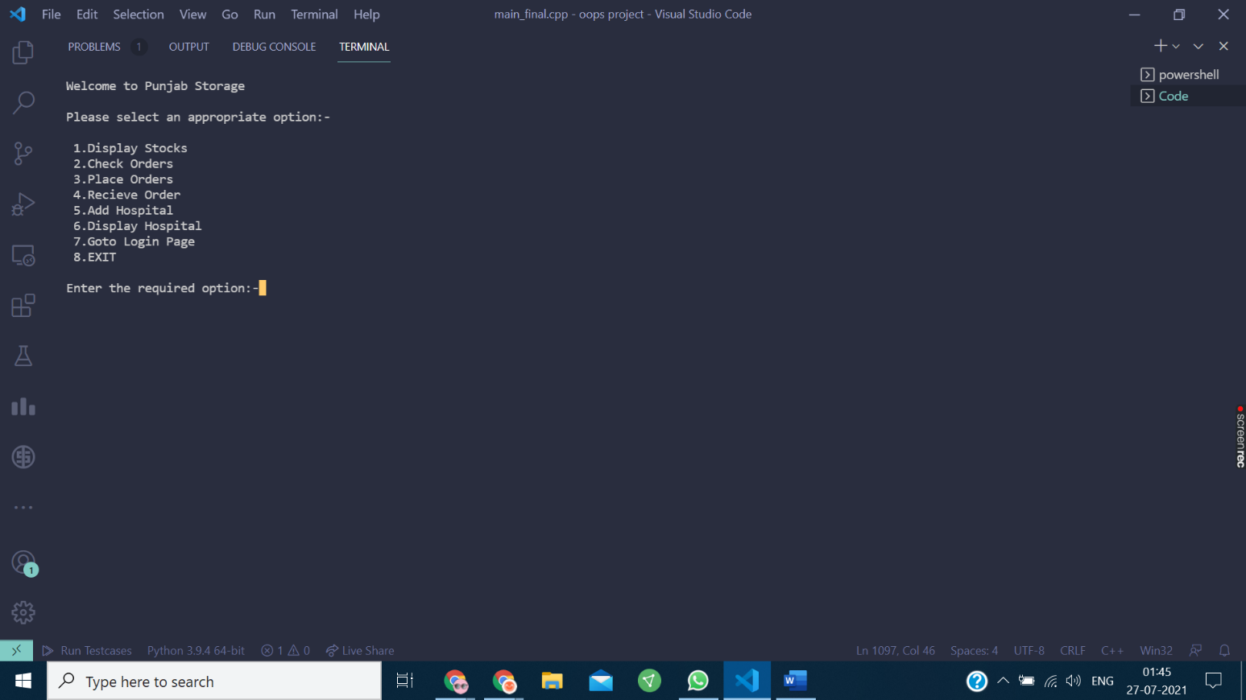

5)REGION INTERFACE

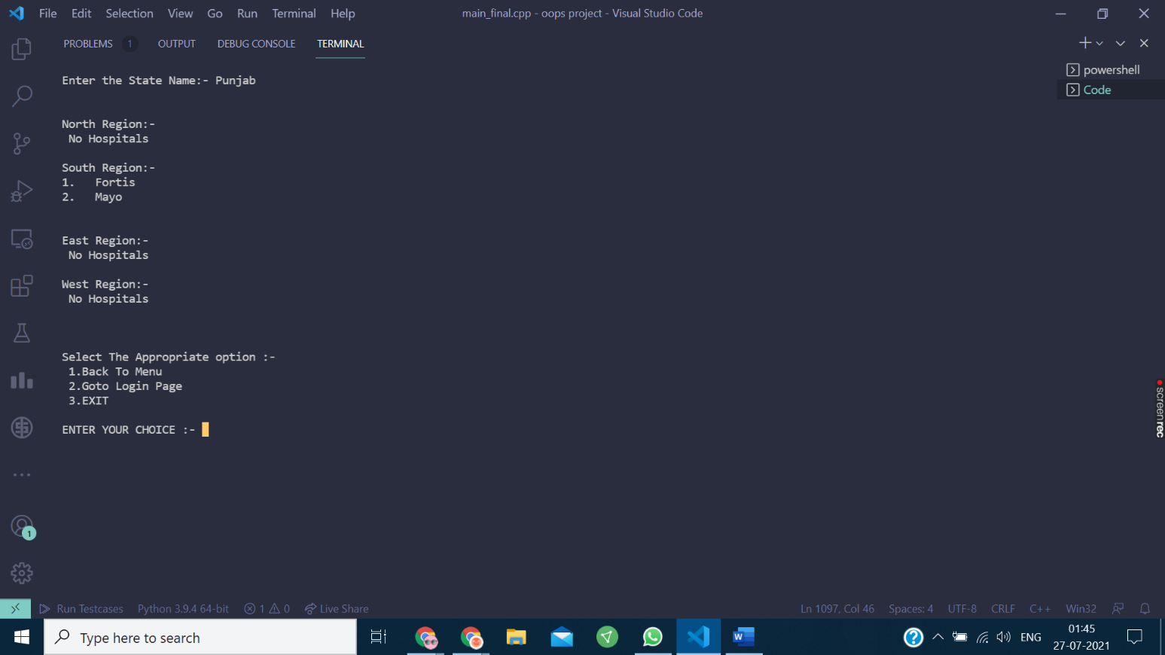

6) HOSPITAL INTERFACE

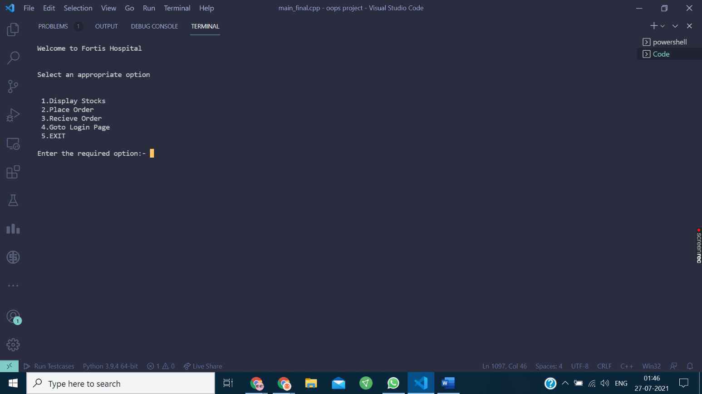

7)WHOLESALER INTERFACE

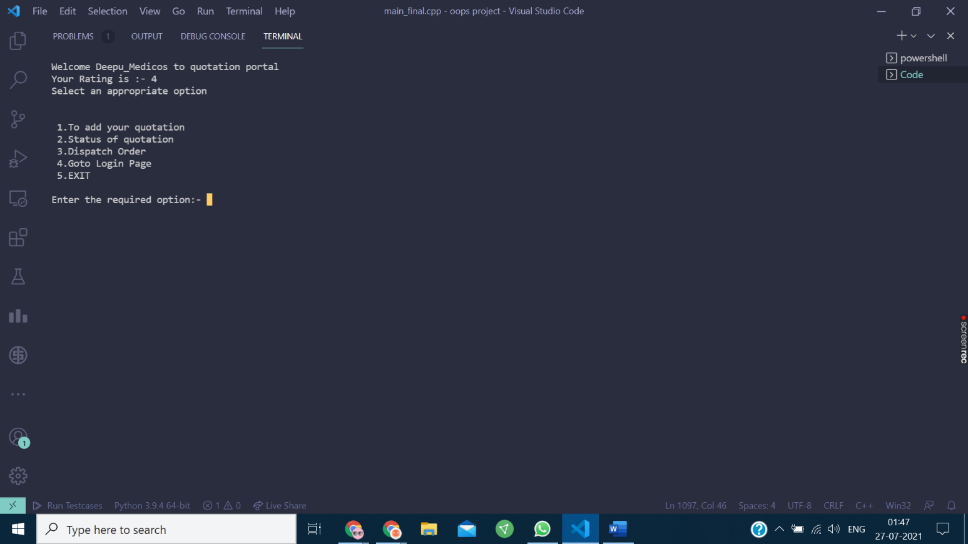

8)DISPLAY STOCKS HOSPITAL INTERFACE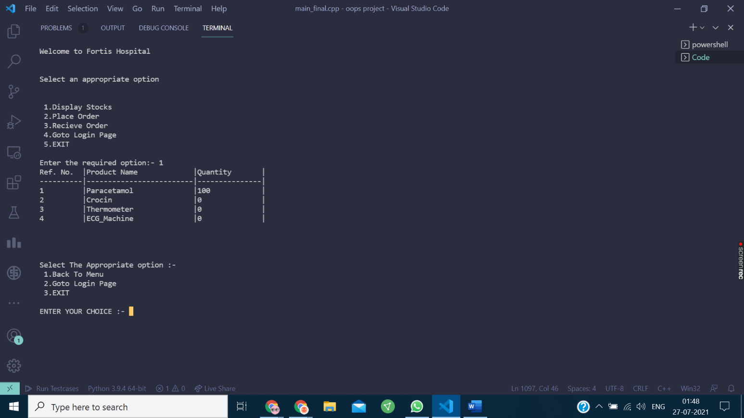

9)LOGIN AND PASSWORD CHECKING INTERFACE

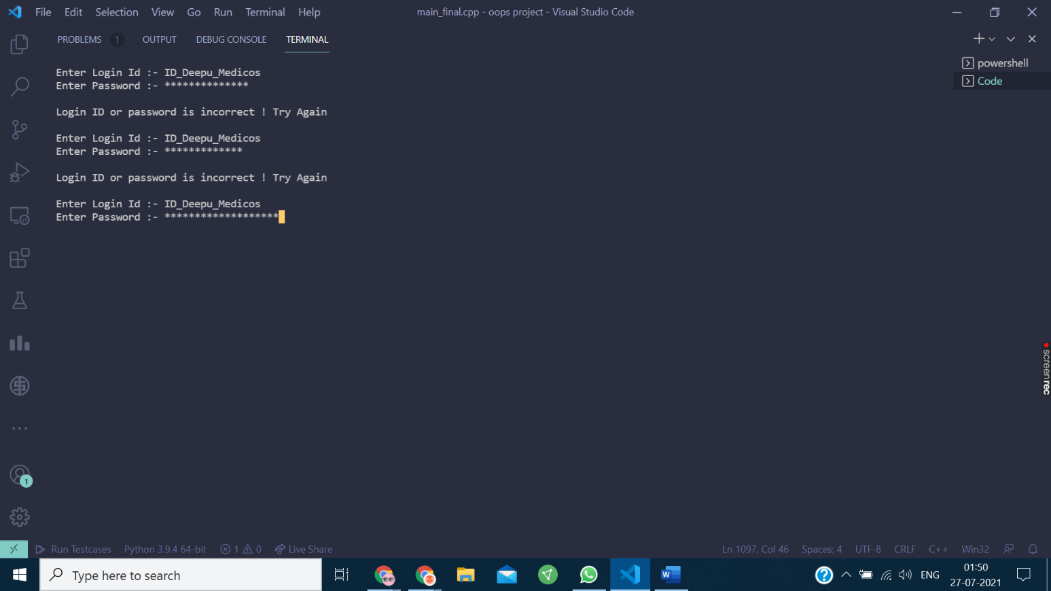10)DISPLAY STOCKS MAIN STORAGE INTERFACE

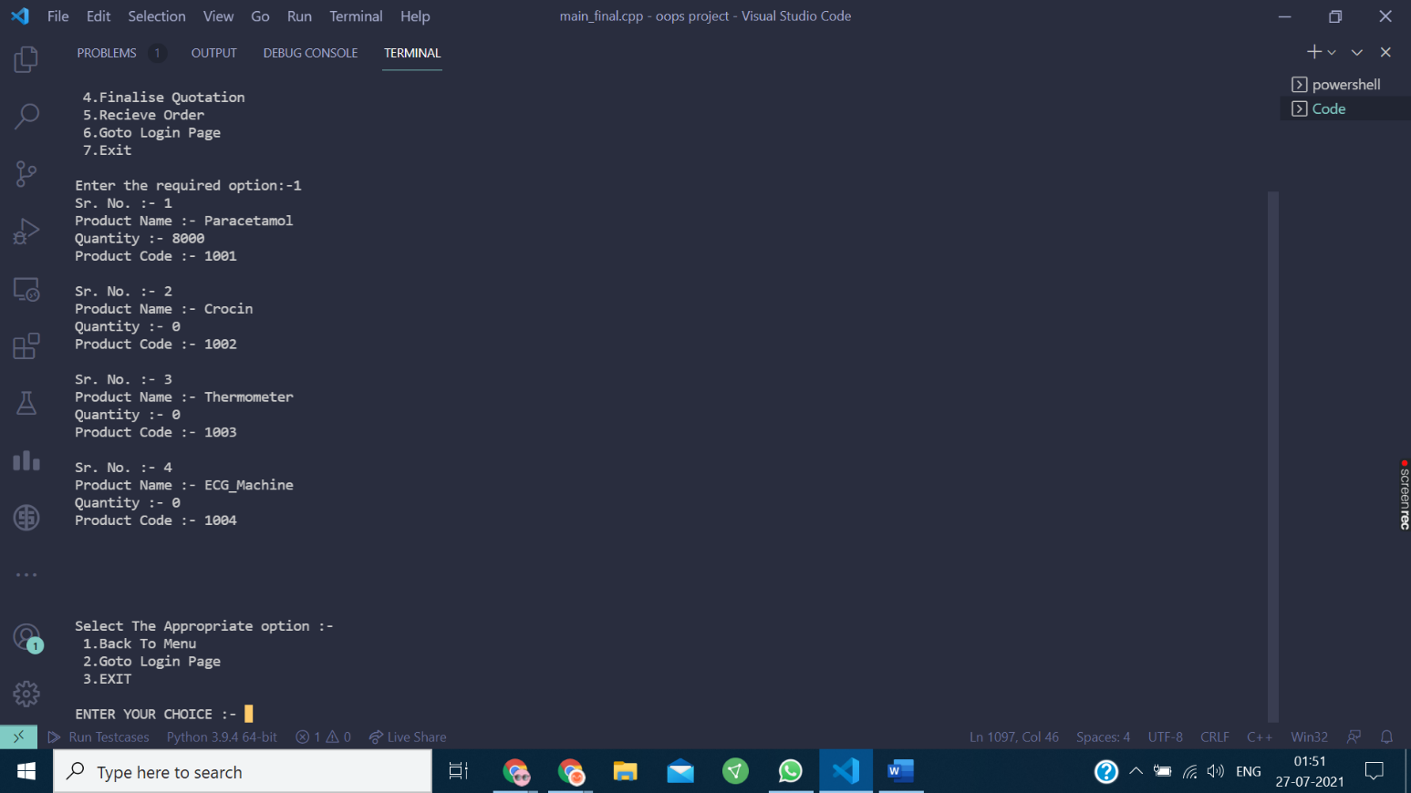

**9. CONCLUSION**

The result obtained is a complete package of program which is able to help the hospital, region and the states to order their required products effectively and at ease.

**10. REFERENCES AND SOURCES**

* Galgotia Publications’ Turbo C++ by Robert and Lafore
* Tata McGraw Hill Publications’ Object-oriented programming with C++ by

E. Balaguruswamy

* Google ( <https://www.google.com/> )
* Geeks For Geeks ( <https://www.geeksforgeeks.org/> )
* Github ( <https://github.com/> )